




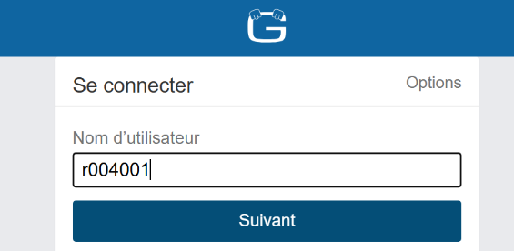
You must log in using your username:
r(student’s file number)
Example: r4040001

Then click on “+Avancé” (Advanced) on top right

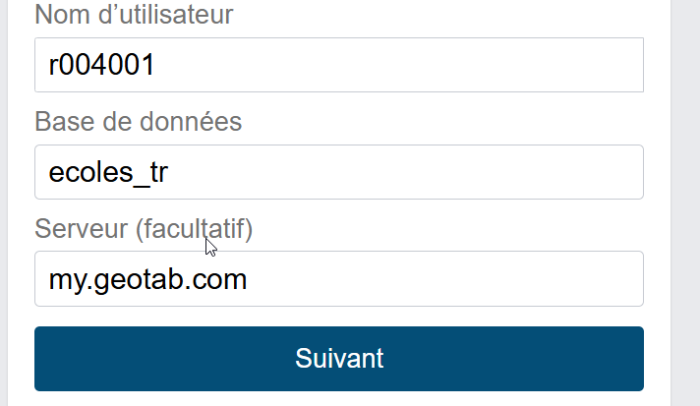
You will need to enter the database: ecoles_tr and then click on “Suivant” (Next).
“Serveur” (Server) stays as is.

You must enter your password under the following configuration:
First 2 letters of the first name +
First 2 letters of last name +
Last 4 digits of your driving license
Example:
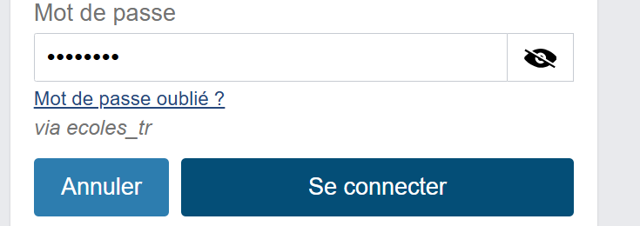
Your name is Jean Prudent
Your licence number is: P0100-040529-03.
Your password will be: jepr2903

Afterwards, you click on
“”Se connecter” (Log in)

