Les états américains

[Alabama](http://www.arizona-dream.com/Usa/cartes/etat/alabama.php) - [Alaska](http://www.arizona-dream.com/Usa/cartes/etat/alaska.php) - [Arizona](http://www.arizona-dream.com/Usa/cartes/etat/arizona.php) - [Arkansas](http://www.arizona-dream.com/Usa/cartes/etat/arkansas.php) - [Californie](http://www.arizona-dream.com/Usa/cartes/etat/californie.php) - [Caroline du Nord](http://www.arizona-dream.com/Usa/cartes/etat/caroline_du_nord.php) - [Caroline du Sud](http://www.arizona-dream.com/Usa/cartes/etat/caroline_du_sud.php) - [Colorado](http://www.arizona-dream.com/Usa/cartes/etat/colorado.php) - [Connecticut](http://www.arizona-dream.com/Usa/cartes/etat/connecticut.php) - [Dakota du Nord](http://www.arizona-dream.com/Usa/cartes/etat/dakota_du_nord.php) - [Dakota du Sud](http://www.arizona-dream.com/Usa/cartes/etat/dakota_du_sud.php) - [Delaware](http://www.arizona-dream.com/Usa/cartes/etat/delaware.php) - [Floride](http://www.arizona-dream.com/Usa/cartes/etat/floride.php) - [Géorgie](http://www.arizona-dream.com/Usa/cartes/etat/georgie.php) - [Hawaii](http://www.arizona-dream.com/Usa/cartes/etat/hawaii.php) - [Idaho](http://www.arizona-dream.com/Usa/cartes/etat/idaho.php) - [Illinois](http://www.arizona-dream.com/Usa/cartes/etat/illinois.php) - [Indiana](http://www.arizona-dream.com/Usa/cartes/etat/indiana.php) - [Iowa](http://www.arizona-dream.com/Usa/cartes/etat/iowa.php) - [Kansas](http://www.arizona-dream.com/Usa/cartes/etat/kansas.php) - [Kentucky](http://www.arizona-dream.com/Usa/cartes/etat/kentucky.php) - [Louisiane](http://www.arizona-dream.com/Usa/cartes/etat/louisiane.php) - [Maine](http://www.arizona-dream.com/Usa/cartes/etat/maine.php) - [Maryland](http://www.arizona-dream.com/Usa/cartes/etat/maryland.php) - [Massachusetts](http://www.arizona-dream.com/Usa/cartes/etat/massachusetts.php) - [Michigan](http://www.arizona-dream.com/Usa/cartes/etat/michigan.php) - [Minnesota](http://www.arizona-dream.com/Usa/cartes/etat/minnesota.php) - [Mississippi](http://www.arizona-dream.com/Usa/cartes/etat/mississippi.php) - [Missouri](http://www.arizona-dream.com/Usa/cartes/etat/missouri.php) - [Montana](http://www.arizona-dream.com/Usa/cartes/etat/montana.php) - [Nebraska](http://www.arizona-dream.com/Usa/cartes/etat/nebraska.php) - [Nevada](http://www.arizona-dream.com/Usa/cartes/etat/nevada.php) - [New Hampshire](http://www.arizona-dream.com/Usa/cartes/etat/new_hampshire.php) - [New Jersey](http://www.arizona-dream.com/Usa/cartes/etat/new_jersey.php) - [New York](http://www.arizona-dream.com/Usa/cartes/routiere/new_hampshire.php) - [Nouveau Mexique](http://www.arizona-dream.com/Usa/cartes/etat/nouveau_mexique.php) - [Ohio](http://www.arizona-dream.com/Usa/cartes/etat/ohio.php) - [Oklahoma](http://www.arizona-dream.com/Usa/cartes/etat/oklahoma.php) - [Oregon](http://www.arizona-dream.com/Usa/cartes/etat/oregon.php) - [Pennsylvanie](http://www.arizona-dream.com/Usa/cartes/etat/pennsylvanie.php) - [Rhode Island](http://www.arizona-dream.com/Usa/cartes/etat/rhode_island.php) - [Tennessee](http://www.arizona-dream.com/Usa/cartes/etat/tennessee.php) - [Texas](http://www.arizona-dream.com/Usa/cartes/etat/texas.php) - [Utah](http://www.arizona-dream.com/Usa/cartes/etat/utah.php) - [Vermont](http://www.arizona-dream.com/Usa/cartes/etat/vermont.php) - [Virginie](http://www.arizona-dream.com/Usa/cartes/etat/virginie.php) - [Virginie-Occidentale](http://www.arizona-dream.com/Usa/cartes/etat/virginie_occidentale.php) - [Washington](http://www.arizona-dream.com/Usa/cartes/etat/washington.php) - [Wisconsin](http://www.arizona-dream.com/Usa/cartes/etat/wisconsin.php) - [Wyoming](http://www.arizona-dream.com/Usa/cartes/etat/wyoming.php).

[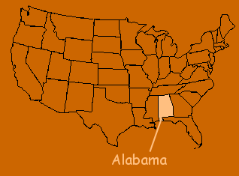](http://www.arizona-dream.com/Usa/cartes/etat/alabama.php)[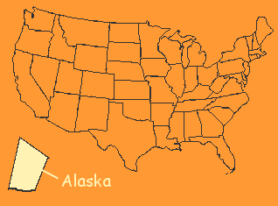](http://www.arizona-dream.com/Usa/cartes/etat/alaska.php)[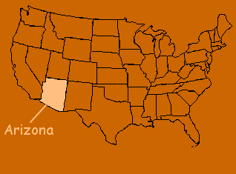](http://www.arizona-dream.com/Usa/cartes/etat/arizona.php)[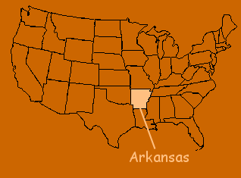](http://www.arizona-dream.com/Usa/cartes/etat/arkansas.php)[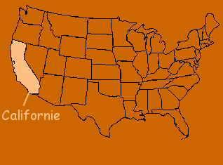](http://www.arizona-dream.com/Usa/cartes/etat/californie.php)[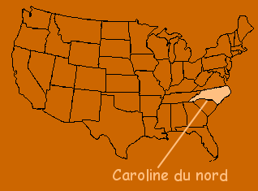](http://www.arizona-dream.com/Usa/cartes/etat/caroline_du_nord.php)

[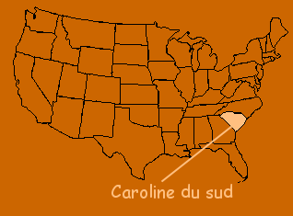](http://www.arizona-dream.com/Usa/cartes/etat/caroline_du_sud.php)[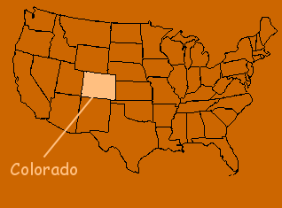](http://www.arizona-dream.com/Usa/cartes/etat/colorado.php)[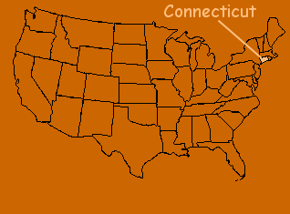](http://www.arizona-dream.com/Usa/cartes/etat/connecticut.php)

[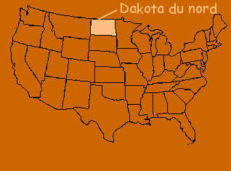](http://www.arizona-dream.com/Usa/cartes/etat/dakota_du_nord.php)[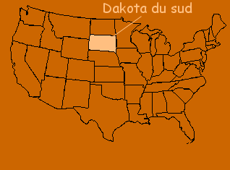](http://www.arizona-dream.com/Usa/cartes/etat/dakota_du_sud.php)[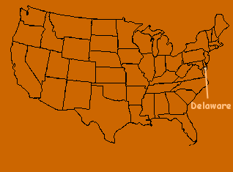](http://www.arizona-dream.com/Usa/cartes/etat/delaware.php)

[Haut de pageRetour en haut de pageHaut de page](http://www.arizona-dream.com/Usa/cartes/etat/index.php#hautdepage#hautdepage)

[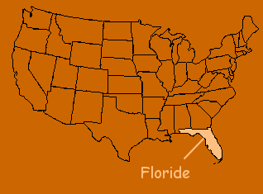](http://www.arizona-dream.com/Usa/cartes/etat/floride.php)[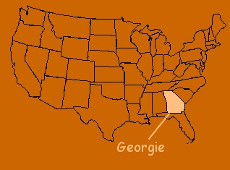](http://www.arizona-dream.com/Usa/cartes/etat/georgie.php)[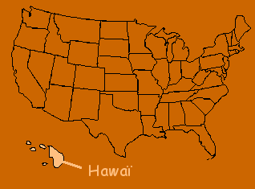](http://www.arizona-dream.com/Usa/cartes/etat/hawaii.php)

[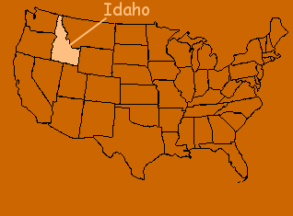](http://www.arizona-dream.com/Usa/cartes/etat/idaho.php)[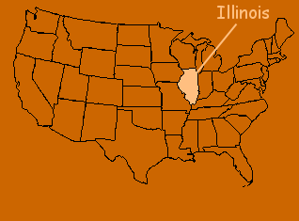](http://www.arizona-dream.com/Usa/cartes/etat/illinois.php)[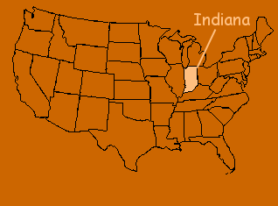](http://www.arizona-dream.com/Usa/cartes/etat/indiana.php)

[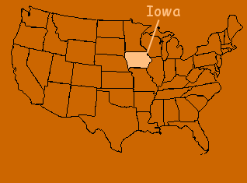](http://www.arizona-dream.com/Usa/cartes/etat/iowa.php)[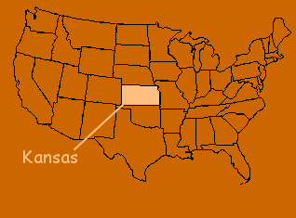](http://www.arizona-dream.com/Usa/cartes/etat/kansas.php)[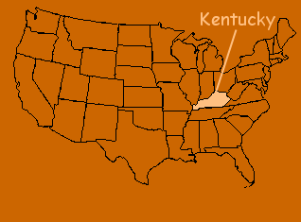](http://www.arizona-dream.com/Usa/cartes/etat/kentucky.php)

[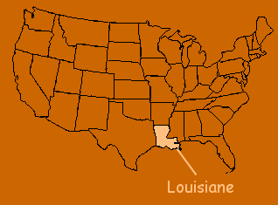](http://www.arizona-dream.com/Usa/cartes/etat/louisiane.php)[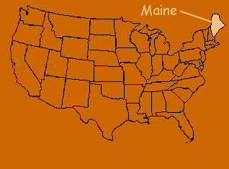](http://www.arizona-dream.com/Usa/cartes/etat/maine.php)[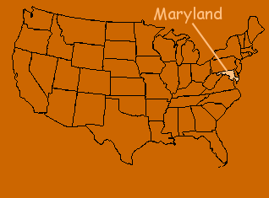](http://www.arizona-dream.com/Usa/cartes/etat/maryland.php)

[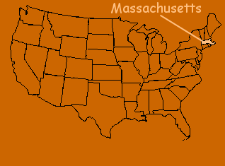](http://www.arizona-dream.com/Usa/cartes/etat/massachusetts.php)[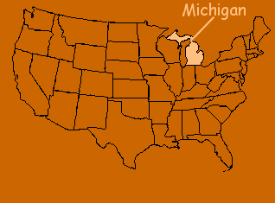](http://www.arizona-dream.com/Usa/cartes/etat/michigan.php)[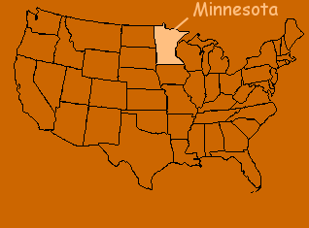](http://www.arizona-dream.com/Usa/cartes/etat/minnesota.php)

[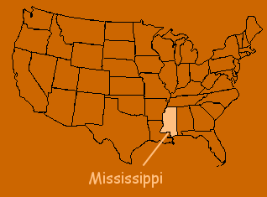](http://www.arizona-dream.com/Usa/cartes/etat/mississippi.php)[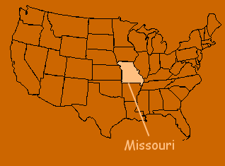](http://www.arizona-dream.com/Usa/cartes/etat/missouri.php)[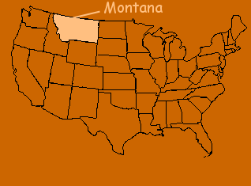](http://www.arizona-dream.com/Usa/cartes/etat/montana.php)

[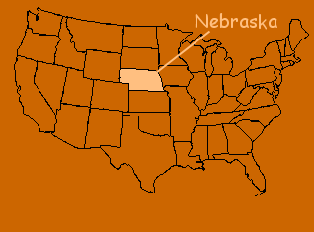](http://www.arizona-dream.com/Usa/cartes/etat/nebraska.php)[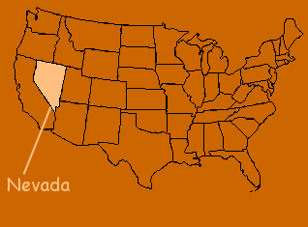](http://www.arizona-dream.com/Usa/cartes/etat/nevada.php)[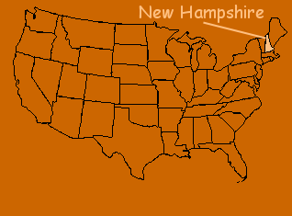](http://www.arizona-dream.com/Usa/cartes/etat/new_hampshire.php)

[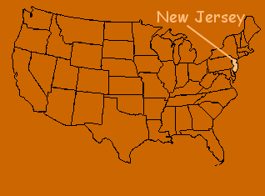](http://www.arizona-dream.com/Usa/cartes/etat/new_jersey.php)[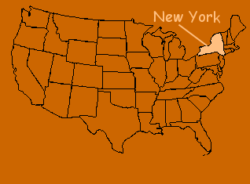](http://www.arizona-dream.com/Usa/cartes/routiere/new_hampshire.php)[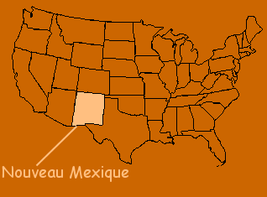](http://www.arizona-dream.com/Usa/cartes/etat/nouveau_mexique.php)

[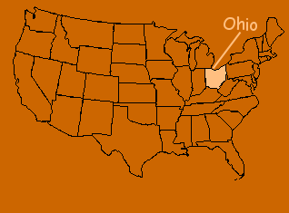](http://www.arizona-dream.com/Usa/cartes/etat/ohio.php)[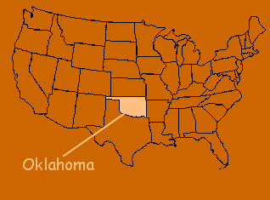](http://www.arizona-dream.com/Usa/cartes/etat/oklahoma.php)[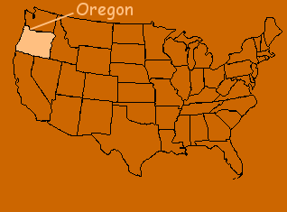](http://www.arizona-dream.com/Usa/cartes/etat/oregon.php)

[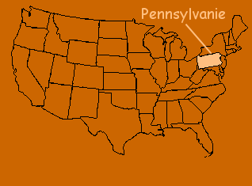](http://www.arizona-dream.com/Usa/cartes/etat/pennsylvanie.php)[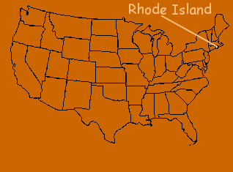](http://www.arizona-dream.com/Usa/cartes/etat/rhode_island.php)[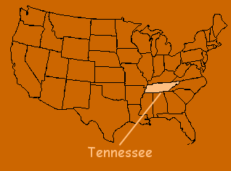](http://www.arizona-dream.com/Usa/cartes/etat/tennessee.php)

[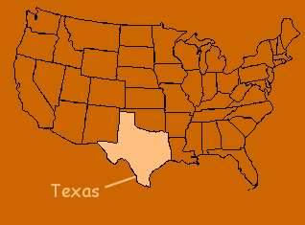](http://www.arizona-dream.com/Usa/cartes/etat/texas.php)[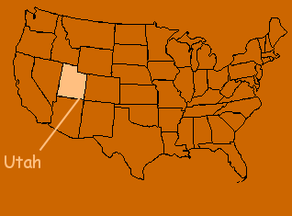](http://www.arizona-dream.com/Usa/cartes/etat/utah.php)[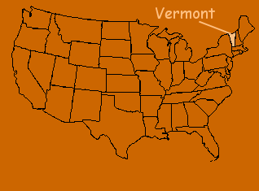](http://www.arizona-dream.com/Usa/cartes/etat/vermont.php)[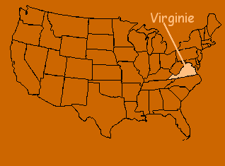](http://www.arizona-dream.com/Usa/cartes/etat/virginie.php)[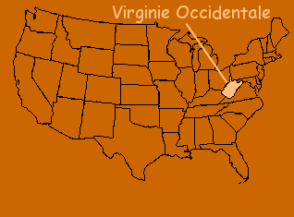](http://www.arizona-dream.com/Usa/cartes/etat/virginie_occidentale.php)[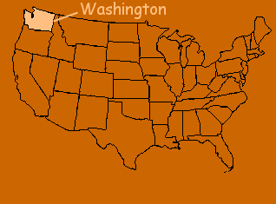](http://www.arizona-dream.com/Usa/cartes/etat/washington.php)

[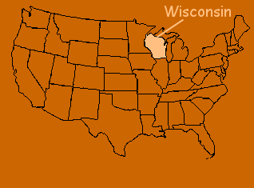](http://www.arizona-dream.com/Usa/cartes/etat/wisconsin.php)[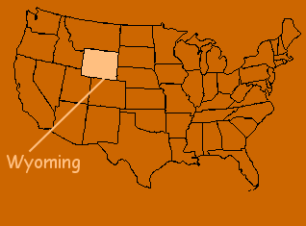](http://www.arizona-dream.com/Usa/cartes/etat/wyoming.php)

Les provinces canadiennes

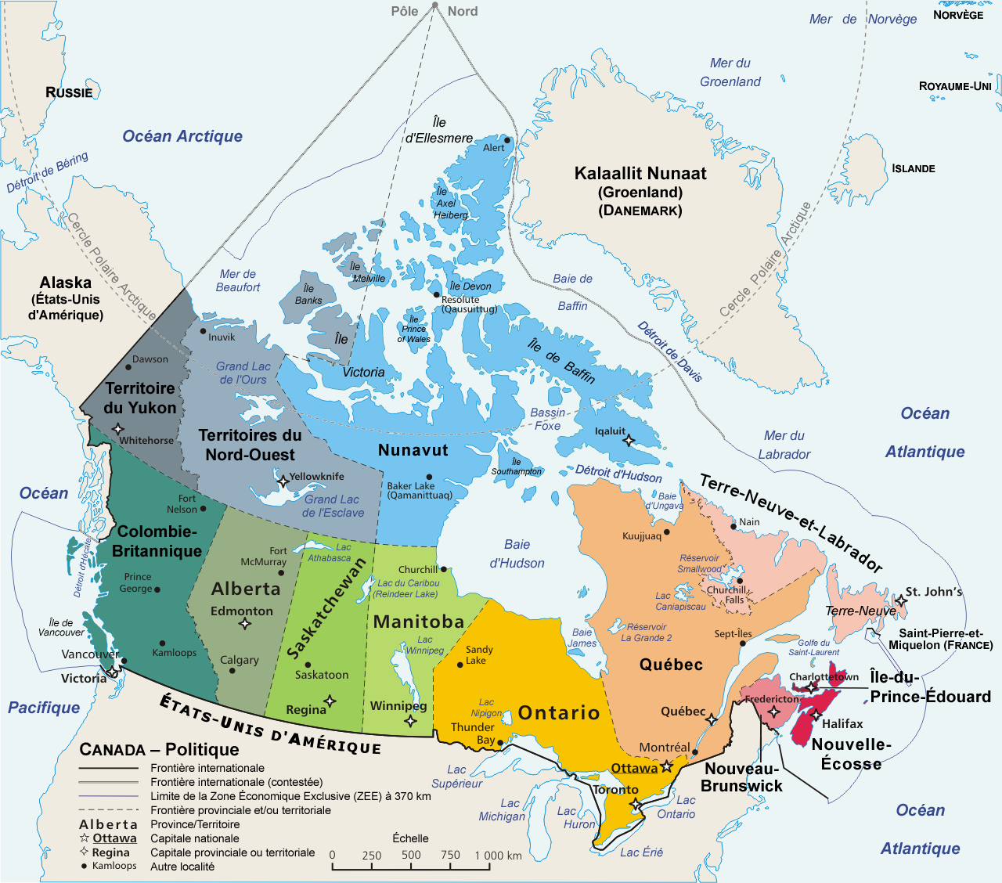

Les régions administratives du Québec

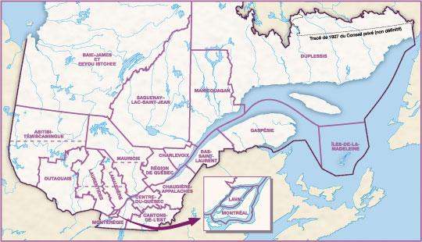

Hyperliens

<http://www.sheppardsoftware.com/Canadian_Geography.htm>

<http://www.yourchildlearns.com/mappuzzle/canada-puzzle.html>

<http://www.yourchildlearns.com/mappuzzle/us-puzzle.html>

<http://www.sheppardsoftware.com/web_games.htm>

<http://www.wwg1.com/quebec/limitesterritoriales/limitesterritoriales.html>

<http://www.quebec511.gouv.qc.ca/fr/index.asp>

<http://www.primarygames.com/states/question_1.htm>

<http://www.mapmsg.com/games/statetris/usa/>

<http://www.arizona-dream.com/usa/divers/jeux-usa-amerindien/replacer_les_etats/index.php> <http://www.arizona-dream.com/Usa/cartes/etat/index.php>